The Why’s, When’s, How’s, and Where’s of PARENTHETICAL NOTES

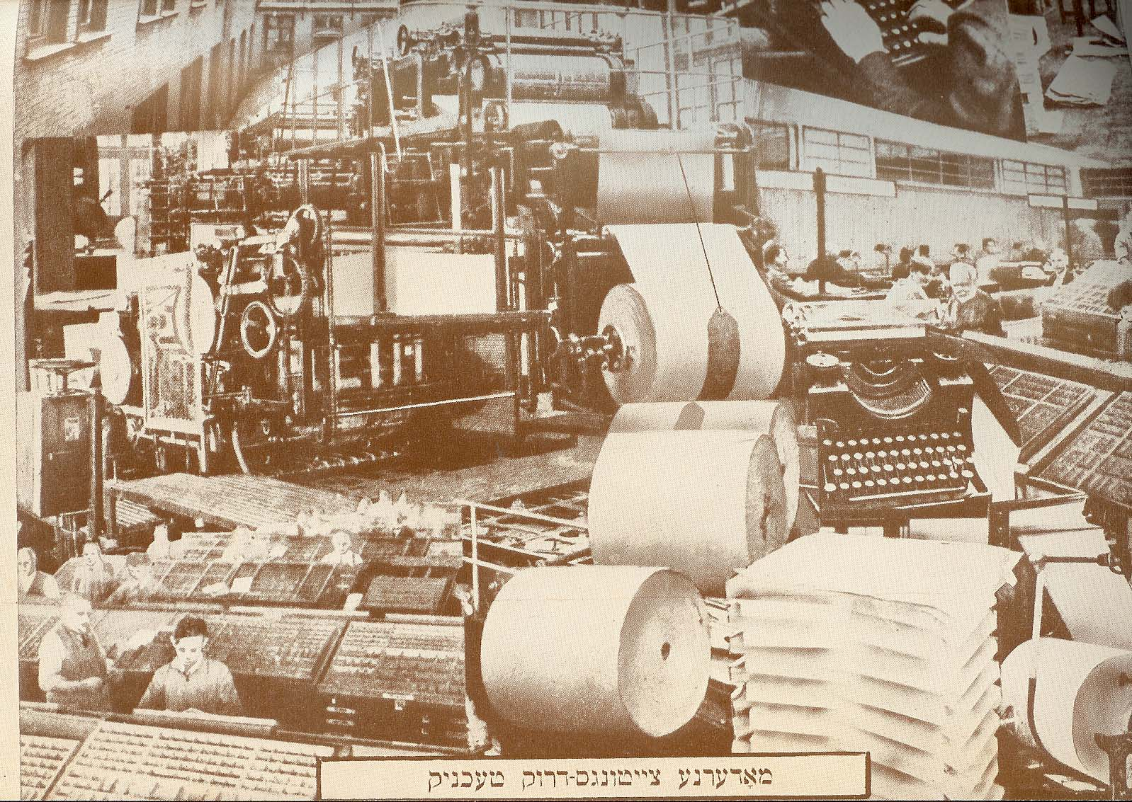
(PN) - Always Cite Your Sources
This information is based on guidelines of the Modem Language Association (MLA). For further Instructions log on to www.mla.org

Parenthetical Notes (PNs), aka. “In-text” notations are the backbone of your paper because they support your information.

The 3 Why's of PNs:
1. To give credit for Information and Ideas that are not your own;
2. To document the accuracy of your Information;
3. To indicate original sources as detailed in your bibliography.

The 6 When's of PNs:
1. Using statistics - measurements and percents;
2. Specific dates for uncommon events;
3. Direct quotations;
4. Lists of Information obtained from a single source;
5. Paraphrasing;
6. Ideas or theories.

The 4 How's of PNs:
1. BOOKS
a. one author - Author’s last name and page # EX. (Keaton 12)
b. 2 books by same author - Author’s name, shortened Title, pg.
EX. (Brown Life in 6th 50)
c. 2 Authors or more - Authors’ last names and page #
(Day & Keaton 89)
d. No Author - Shortened Title and page
EX (8th Grade Goes 51)
e. Editor - Editor’s last name and page EX. (Smith 34)

2. ARTICLES
a. Newspaper/Magazine w/ Author - Author’s last name and page #
EX. (Carl 34)
b. Newspaper / Magazine w/o Author - "Shortened Article Title" pg.
EX. ("Youth Sports" 51)

3. INTERVIEWS.
a Interviewed once - Last name EX. (Cannon)
b. Interviewed more than once - last name & date EX. (Keaton 2/3/02)

4. WORLD WIDE WEB PAGES
a. One author - Author Shortened URL (Ainsworth ASDS.org)
b. No Author - "Shortened Article Title" URL. ("Library" ASDS.org)

The 3 Where's of PN’s:

1. WITH BRIEF QUOTATIONS, PARAPHRASES, IDEAS/THEORIES/LISTS:
-Immediately following the last word or quotation mark but before the
final period. EX.
....a Welsh prince discovered Florida (Keaton 9/15/02).

2. WITH BLOCK QUOTATIONS ( LONGER THAN TWO LINES):
-Indent and single space the text, do not use quotation marks and put
Citation after the ending punctuation mark. EX.
Alexander's conquests made him the ruler of a
multi-cultural empire, or an empire of many cultures
which stretched from the Greek mainland to the Indus.
(Boehm 320)

3. WITH STATISTICAL INFORMATION OR DATES:
-Immediately following the numbered item. EX.

The army Included 300 chariots and 200 elephants (Boehm 321)
which made it very mobile.
OR
Sailing westward from Ireland, a small group of Irish Monks visited Middle America between 800 and 1000 AD (History's Mysteries 45) as part of a missionary expedition.

