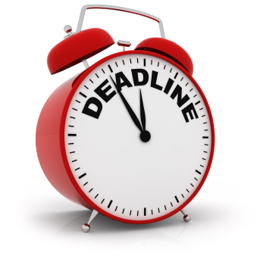 History Day @ All Saints’ 2015

Websites – Progress Timeline

During the month of January, you will be have two meetings with Mr. Day or Miss Keaton to discuss your progress on your project.

This timeline is a guideline. Tasks maybe completed and texts submitted sooner but NOT later than these date. Please share your URL with Mr. Day and Miss Keaton.

P1. Website Designed – 1/9/15

All major pages/links set up

Share URL with Mr. Day and Miss Keaton

1. Annotated Bibliography I due for all 1/13/15

P2. Home Page and

2 Major Menu Pages Completed 1/20/15

2. Process Paper I due for all 1/23/15

P3. 3rd Major Menu Page Completed 1/26/15

3. Annotated Bibliography II due for all 1/30/15

P4. 4th Major Menu Page Completed 2/2/15

4. Process Paper II due for all 2/6/15

P 5. Last day to submit RD Page texts for editing 2/10/15

Email/Goo Doc

P 6. Winter Break - make text corrections, 2/14/15 – 2/22

Add *AB/PP to Sources page, finalize inactive*

*features and check all links.*

*P7.* Websites Published *(11:00 PM) 2/23/15*

*Confirmation emailed to Lyceum*

*email:* [*Joyce@lyceum.org*](mailto:Joyce@lyceum.org)

*P7 Attend HD Interview* 3/7/15

*Los Arbolos Middle School, Marina*

*Bring a copy of your PP and AB with you*

*Attend Awards Ceremony*