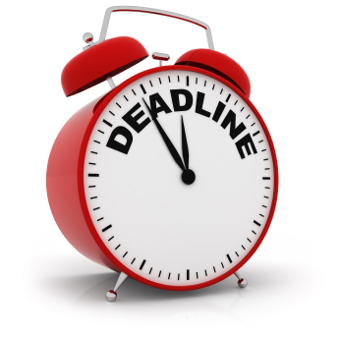 History Day @ All Saints’ 2015

Documentaries – Progress Timeline

During the month of January, you will be have two meetings with Mr. Day or Miss Keaton to discuss your progress on your project.

This timeline is a guideline. Tasks maybe completed and review of segments conducted sooner but NOT later than these date. Please share your URL with Mr. Day and Miss Keaton.

P1. Major Segments Designed 1/9/15

Written Title Frame for each

Share URL with Mr. Day and Miss Keaton

1. Annotated Bibliography I due for all 1/13/15

P2. 1st Major segment Completed 1/20/15

2. Process Paper I due for all 1/23/15

P3. 2nd Major segment Completed 1/26/15

3. Annotated Bibliography II due for all 1/30/15

P4. 3rd Major Menu Page Completed 2/2/15

4. Process Paper II due for all 2/6/15

P 5. Last day to review Doc w/Mentor for editing 2/10/15

P 6. Winter Break – finalize documentary 2/14/15 – 2/22

Be sure to end with *Credits*

*P7.* Documentary uploaded to Vimeo *2/23/15*

*Confirmation and AB/PP emailed to Lyceum*

*Email:* [*Joyce@lyceum.org*](mailto:Joyce@lyceum.org)

No later than  *(11:00 PM)*

*P7 Attend HD Interview* 3/7/15

*Los Arbolos Middle School, Marina*

*Bring a copy of your PP and AB with you*

*Attend Awards Ceremony*