**A Research Roadmap - Abridged**

by Jodi Vandenberg-Daves, University of Wisconsin-La Crosse

Like professional historians, National History Day students must:

1. Ask questions about their topic's significance in history,
2. Do background research using secondary sources to understand the context of their topic,
3. Interpret primary sources in order to answer questions about their research topics.

As you do this, you are making history! How do you do this? This road map will set you on the right path and help you get where you are going.

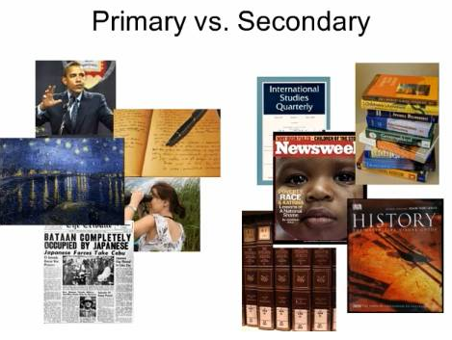**What's the difference between a primary source and a secondary source when you're doing research?**

A **secondary source** is a book or article written by an author who is not an eyewitness or a participant in the historical event or period.

For example:

1. High school history textbooks
2. History books about a particular topic
3. Biographies
4. Reference books, such as encyclopedias, scholarly

Journals and publications

1. Television documentaries

A **primary source** is material written or produced in the time period students are investigating.

For example:

1. A letter written by President Lincoln in 1862 is a primary source for a student researching the Civil War.
2. The diary of a person who was part of Cesar Chavez's labor union movement AND
3. An oral history interview with the same person in 2015 as an eyewitness to the historical event.

Now, to get started on your research . . ..

**Secondary sources give you background and lead you to the primary sources.**

Why start with secondary sources?

They will help you to understand:

1. How to place your topic in the larger historical perspective and context.
2. Why your topic is important
3. How it relates to economic, social and political developments of the period.

What are Secondary Sources?

1. Resources based on primary sources, that is, documents and other evidence created by participants or eyewitnesses.
2. Textbooks are based on secondary sources written by other historians.
3. Their Bibliographies and notes can direct you to some major primary and secondary sources.

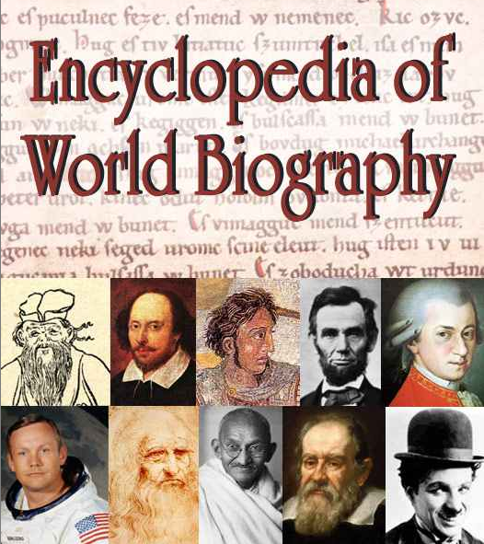 **REFERENCE BOOKS**

General information: encyclopedias, special historical dictionaries, and historical atlases.

1. *World Book*, *Britannica*, etc.
2. Subject encyclopedias such as the *Encyclopedia of the North American*

*Colonies* or the *Encyclopedia of American Economic History*

1. Biographical dictionaries are compilations of biographies of people

Selected because of their fame:

* 1. *Dictionary of American Biography*, *World Biography*
  2. *Notable American Women*,
  3. *Biographical Dictionary of Members of Congress*

1. 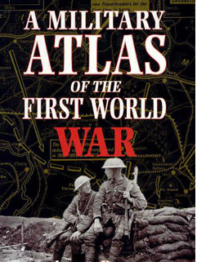Atlases are compilations of maps. Examples:
   1. Lester J. Cappon's *Atlas of Early American History*,
   2. James McPherson's *The Atlas of the Civil War*,
   3. *Latin American History: A Teaching Atlas*.

**

**POPULAR PERIODICAL LITERATURE**

Popular magazines and newspapers that are usually are written in a conversational style and often well-illustrated, and are indexed in the *Readers’ Guide to Periodical Literature*

1. National Geographic provides general information on provocative topics.
2. Popular historical magazines include American History Illustrated, Civil War Times, and American Heritage.
3. *Time, Life, Newsweek*
4. *Popular Mechanics, Art News*
5. *TV Guide, Variety, Rolling Stone*

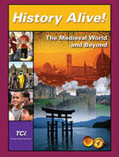**HISTORY TEXTBOOKS**

Yes, really! Your textbook can be a great place to find out about the general historical context of your topic…. how it fits into the bigger picture:

Example:

-Topic: Exploring the telescope’s revolutionary effect on astronomy

- Historical context: background readings:

* The Scientific Revolution,

* European History 17th & 18th centuries

**GENERAL HISTORICAL WORKS AND MONOGRAPHS**

A book on specific topics will provide more detail than a general history text. Use keywords to search for references on a specific subject, event, person, etc.

1. The American Historical Association’s Guide to Historical Literature, 3rd ed. (New York: Oxford University Press, 1995).
2. Monographs are full-length books dealing with a relatively narrow topic and typically are intended for people with some background in the subject.
3. Popular books include picture books or other books aimed at a general audience:
   1. The Oxford Illustrated History of the British Monarchy,
   2. Popular Mechanic's Picture History of American Transportation,

c. Tom Brokaw's The Greatest Generation.

**JOURNAL ARTICLES**

Historians don't always write books. Smaller essays on specific topics can be found in scholarly journals; these are periodicals similar to magazines, only focused on history topics. They usually include extensive footnotes or endnotes, and bibliographies that can direct you to some major primary and secondary sources

1. American Historical Review,
2. Journal of American History,
3. California History Quarterly,
4. Journal of Economic History, Past and Present
5. History of Education.

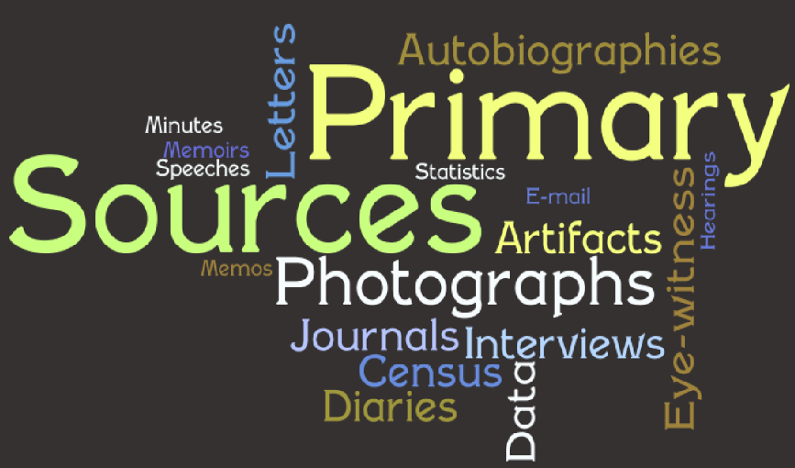

**Getting acquainted with primary sources.**

Here are some basic kinds of primary sources:

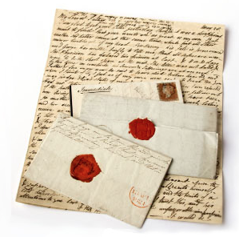

LETTERS, DIARIES, AND OTHER FIRST-PERSON NARRATIVES

Diaries, letters, or reminiscences of revolutionary soldiers, political activists, or government officials.

1. *American Diaries*.

2. *Early American Imprints*, which reproduces every book, pamphlet, and

broadside published in America before 1820.

3. *The English Short-Title Catalogue*, 1473 to 1800. Early English books

including many primary sources relating to European history, and

foreign travel narratives written by English visitors.

MANUSCRIPT/PAPER COLLECTIONS OF ORGANIZATIONS, PROMINENT INDIVIDUALS, OR FAMILIES

These include letters, memos, reports, statements of purpose, plans for projects, deeds, wills, etc.

1. Online National Union Catalogue of Manuscript Collections
2. Collections of state and local historical societies, churches and other organizations
3. University libraries often have special collections about alumni, donors, or local families or businesses.
4. Examples
5. [California History Room - Monterey Library](http://www.monterey.org/library/History-Room/Archives)
6. [Regional Oral History Project - UCBerkeley](http://bancroft.berkeley.edu/ROHO/projects/arts_ca/index.html)
7. [Online Archive of California:](http://www.oac.cdlib.org/)

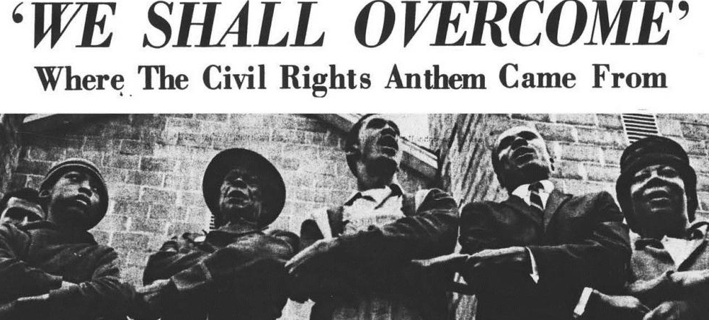SONGS AND HYMNS

Both words and music can be interpreted as an expression of an era or promoting a point of view or call to action.

1. Songbooks or recordings in local public or university library.
2. American Memory Project - Library of Congress includes many songs.
3. American Folk life Center - - Library of Congress

PHOTOGRAPHS

Historical photographs are the mid-nineteenth century to the present. Sources include:

1. Books, magazines, newspapers
2. Collections, archives, albums
3. National Archives – ["Picturing the Century"](http://www.archives.gov/exhibits/picturing_the_century/home.html)

Look at the Research Links section of the National History Day home page for sources.

TOOLS, MACHINES, BLUE PRINTS, FURNITURE, AND OTHER ARTIFACTS

You can find artifacts at museums, historical societies, or historic sites. You might even find something you can use at a local antique store or flea market or even in your grandparents’ attic.

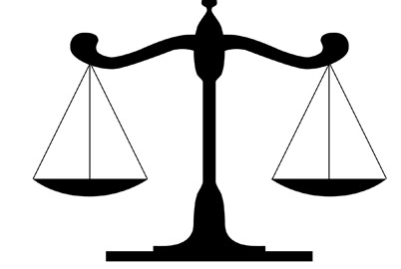

COURT PROCEEDINGS

Proceedings of trials and court decisions.

1. Records for local and state courts - state archives or at the appropriate courthouse.

2. Federal court records are available at the National Archives.

3. [Supreme Court](http://www.supremecourt.gov/)

4. Court Decisions and laws [FindLaw](http://public.findlaw.com/)

GOVERNMENT RECORDS, INCLUDING CENSUS DATA

1. [US Census](http://www.census.gov/)
2. [National Archives and Records Administration](http://www.archives.gov/)
3. Colonial and state records through the early 19th century -microfilm collection called The Records of the States of the United States.

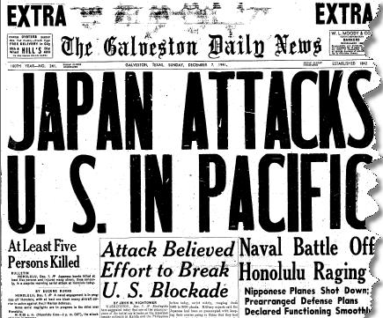

NEWSPAPERS AND MAGAZINES

Newspaper or magazine articles from the time period provide eyewitness accounts.

1. [New York Times](http://hn.bigchalk.com/hnweb/hn/do/search)
2. 20th-century magazines -Readers’ Guide to Periodical Literature
3. 19th-century magazines - Poole’s Index to Periodical Literature
4. Archives - Time, Newsweek, and Harper’s Weekly.
5. [Making of America Project](http://digital.library.cornell.edu/m/moa/)
6. [Chronicling America to 1922](http://chroniclingamerica.loc.gov/)
7. [Newspaper Archives](http://www.newspapers.com/)

**Note:** Newspapers or magazines published during the time period you are researching are primary sources. A newspaper article published in 2001 commemorating the Russian Revolution of 1917 is not a primary source.

ORAL HISTORY INTERVIEWS

An oral history interview is a focused interview with someone about his/her past and role in history.

1. Collections of Oral histories

a. [Oral History Interviews](http://www.aaa.si.edu/collections/interviews): Archives of American Art – Smithsonian Institution

b. [Oral History Project LSU](http://www.louisianadigitallibrary.org/cdm/landingpage/collection/THW)

c. [Regional Oral History Project - UCBerkeley](http://bancroft.berkeley.edu/ROHO/projects/arts_ca/index.html)

d. [Historical Voices](http://www.historicalvoices.org/): interviews with historical people

e. [WWII Oral Histories](http://www.ww2online.org/)

f. [American Memories - Faces and Voices](http://memory.loc.gov/ammem/browse/index.html)

2. You can conduct an oral history interview yourself… [Oral History Guidelines](http://www.nationalww2museum.org/learn/education/for-students/oral-history-guidelines.html?referrer=https://www.google.com/)

**Note:** An interview with an expert on the history of the American Revolution is not a primary source but may be a very good secondary source.

**Finding the primary sources you need for your topic**



*Make Contact* - Place phone calls, send e-mail, or write to living historical figures--famous and not famous.

*60 Year Window* - Chances are you can find someone who participated in or experienced it first-hand.

*In Your Community* – locate people who have: been part of civil rights activities, protested government actions, worked for reforms, or fought for freedom at home or abroad.

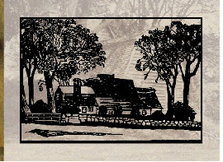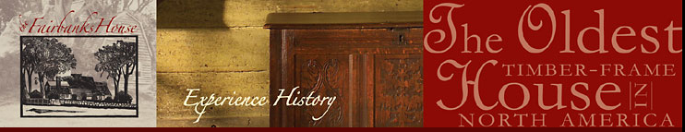*Visit Historic Sites* – on your visit find an expert at the site who has done a lot of research and may have or know of some great sources.

[Historic Sites](http://www.preservationnation.org/)

[National Park Service](http://www.nps.gov/history/)

[National Registry](http://www.nationalregisterofhistoricplaces.com/)

**Some examples of where primary and secondary sources can be found.**

**THE INTERNET**

Using the National History Day home page, you can get connected to great online resources, including many online primary sources. Within the [NHD Research page](http://www.nhd.org/entering-contest/#toggle-id-2) are links to:

* Organizations and Institutions
* Museums & Historic Sites
* National Libraries, Archives & directories
* U.S. History Primary Sources and Major Websites
* World History Primary Sources and Major Websites
* Photos, Maps, and Other Images
* Music

**LIBRARIES**

Do not rely only on the Internet, HD is about finding a broad range of source, including PRINT materials like books, magazines, and newspapes.



School Library

• Encyclopedias

• History textbooks

• General historical works

* Reference Books

• Access to the Internet

Public Library – beyond the school library

• Access to interlibrary loan

• Video documentaries

• Some historical monographs

• Historical novels (e.g., Theodore Dreiser's novel Sister Carrie could serve as a primary source in its

descriptions of the industrial revolution.)

• Clipping files: newspaper and magazine accounts of local events

• Special collections of various resources

• Newspapers and magazines

* Popular magazine collections

University Libraries

• History journal articles

• General historical works and monographs

• Historical atlases (e.g., a map showing major battles in the Chinese revolution)

**MUSEUMS, COLLECTIONS, VIDEO “STORES”, ANTIQUE STORES, E-BAY**

Art Museums

Works of art can serve as primary sources and can add a great deal to the visual dimensions of

your project.

Check out collections with historical significance:

• Paintings • Sculptures • Photographs

Collections and Galleries

[Smithsonian Institution](http://www.si.edu/)– largest collection of artifacts in the world

[National Portrait Gallery - U.S.A.](http://www.nationalportraitgallery.org/)

[Historic Car Collections](http://usclassiccars.blogspot.com/)

Local or Online Video Stores

• Popular films (reflect the concerns of the decades they were made)

Example: *Casablanca* (1943)” is part of the history of the 1940s. It portrays wartime

refugees in Morocco, and it is very revealing of Americans' perspectives on the role of the United States in the world during World War II

• Popular television shows

• Music videos

• Documentaries (NOT docudramas of historical events)

• Newsreels

Antique Stores, E-Bay

• Historical artifacts such as tools, old books and magazines, etc.

• Photo albums, post cards, posters

**HISTORY IS EVERYWHERE! EVEN IN YOUR HOUSE.**

Look around for:

• Personal records, such as diaries and letters

• Family and household records

• Photo albums

• Home movies and videos

**STATE AND LOCAL HISTORICAL SOCIETIES AND ARCHIVES**

Ever wonder what's inside those buildings in your community or state capital? Go find out! Make a few phone calls or check out the institution’s web site. Take lots of paper for note taking and some change for copying because the historical documents cannot be checked out. Organizations donate their historical records to historical societies but a few, like the Y.M.C.A. or the Boy Scouts of America even establish their own archival collections.

Societies

Kinds of documents you can find:

• Manuscript Collections

• Letters and Diaries

• Papers of prominent local individuals and families

• Papers of state and local organizations- state political parties, boards of education, and foundations

• State and local newspapers (some may be indexed by topic)

• Oral history collections • Records of government agencies

• Records of births, marriages and deaths

• Collections of photographs

• Brochures and pamphlets

• Reports of state commissions on various subjects, such as education, commerce or crime

• Historical object collections

Organizations

Types you can try:

• Churches and synagogues

• Fraternal organizations - Freemasons

• Ethnic societies - Irish-American Society of America

• Political parties or other political organizations – NAACP, AAUW

• Corporations

• Veterans groups

• Charities

**Interpreting those primary sources**

As you puzzle out the meaning of these sources, here are some things to keep in mind:

* Don't forget that the historical event or issue you're researching took place in a particular historical context.
* Be sure to review secondary material as you interpret the primary sources. This will help you think through the significance of your topic in history.
* Don't assume that your sources contain the "truth" about an event. Historians need to be skeptical about every source they find, including Internet sources.

Here are some questions to ask yourself in order to determine just how much a particular source really tells you about the past:

• Why are the sources you've chosen useful for answering the questions you want answered?

• What kind of information is not revealed by the sources you have (and may never be revealed because we can never know all the details of a historical event)?

• Who is the author/producer/storyteller?

• Why did they produce this document, paint this painting, or decide to tell you their story?

• Who was the intended audience?

• What was the purpose of the letter, diary, speech, etc.?

• In what kinds of situations were those songs sung, or those farm implements used?

• What are the key biases you see in this source?

• How much can we find out about the people whose voices do not appear in a particular document, from the perspective of the people who left written information?

• Who preserved this source of historical information and why?

• Do the various primary sources you've collected give you conflicting information? Why?

• How does what you learned from one photograph complement--or contradict-- what you learned from a newspaper account?

• What do you know about the larger historical context (you know, the stuff you learned about in history class!) that can help you understand the particulars you find in your primary sources?

• How might the story you're uncovering as you research this topic relate to other episodes in history?

