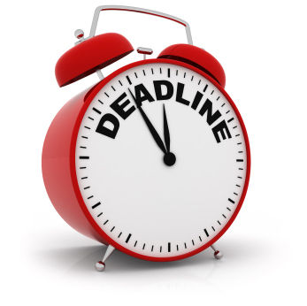
History Day @ All Saints’ 2015

Websites – Progress Timeline

During the month of January, you will be have two meetings with Mr. Day or Miss Keaton to discuss your progress on your project.

This timeline is a guideline. Tasks maybe completed and texts submitted sooner but NOT later than these date. Please share your URL with Mr. Day and Miss Keaton.

P1. Website Designed – 1/9/15
All major pages/links set up
Share URL with Mr. Day and Miss Keaton

- Annotated Bibliography I due for all 1/13/15

P2. Home Page and
2 Major Menu Pages Completed 1/20/15

2. Process Paper I due for all 1/23/15

P3. 3rd Major Menu Page Completed 1/26/15

3. Annotated Bibliography II due for all 1/30/15

P4. 4th Major Menu Page Completed 2/2/15

4. Process Paper II due for all 2/6/15

P 5. Last day to submit RD Page texts for editing 2/10/15
Email/Goo Doc

P 6. Winter Break - make text corrections, 2/14/15 – 2/22
Add AB/PP to Sources page, finalize inactive
features and check all links.

P7. Websites Published (11:00 PM) 2/23/15
Confirmation emailed to Lyceum
email: Joyce@lyceum.org

P7 Attend HD Interview 3/7/15
Los Arbolos Middle School, Marina
Bring a copy of your PP and AB with you
Attend Awards Ceremony

